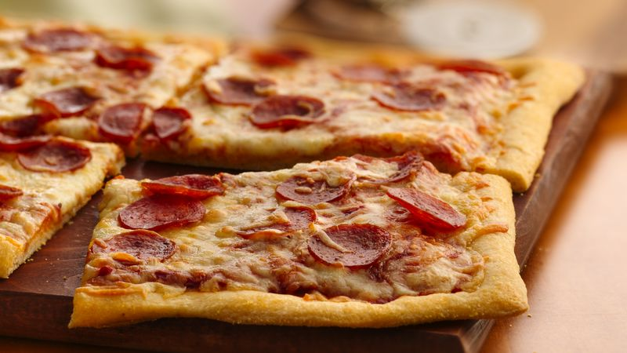
Pepperoni Pizza
Prep Time 10 minutes
4 Servings

Ingredients
1 can (13.8 oz) Pillsbury refrigerated classic pizza crust
- or -
1 can (11 oz) Pillsbury refrigerated thin pizza crust
1 can (8 oz) pizza sauce
½ cup or more sliced pepperoni
1 cup shredded mozzarella cheese (4 oz)
1 tbsp grated Parmesan cheese
Directions
Thin crust, dark or nonstick pan - Heat oven to 400 degrees.
Classic crust or all other pans - Heat oven to 425 degrees.
- Spray or grease 15x10-inch or larger dark or nonstick cookie sheet.
- Unroll dough on cookie sheet. Starting at center, press dough into 15x10 inch rectangle.
Bake
- Spread pizza sauce over crust to within ½ inch of edges. Top with pepperoni and mozzarella cheese. Sprinkle with Parmesan cheese.
- Bake classic crust 14 to 18 minutes, thin crust 8 to 12 minutes, or until crust is golden brown. Rotate the pan 180 degrees half-way though cooking time. Cut pizza into 6 rows by 3 rows.

